МІНІСТЕРСТВО ОСВІТИ I НАУКИ УКРАЇНИ

НАЦІОНАЛЬНИЙ ТЕХНІЧНИЙ УНІВЕРСИТЕТ УКРАЇНИ

«КИЇВСЬКИЙ ПОЛІТЕХНІЧНИЙ ІНСТИТУТ   
ІМЕНІ ІГОРЯ СІКОРСЬКОГО»

ФАКУЛЬТЕТ БІОМЕДИЧНОЇ ІНЖЕНЕРІЇ

КАФЕДРА БІОМЕДИЧНОЇ КІБЕРНЕТИКИ

**Комп’ютерний практикум № 4**

з дисципліни «**Методи та системи штучного інтелекту**»

на тему: «МОДЕЛЮВАННЯ ШТУЧНОЇ ЕКГ З АЛЬТЕРНАЦІЄЮ ЗУБЦЯ Т»

**Виконала:**

студентка гр. БС-12

Сипко В.І.

**Перевірив:**

доц. каф. БМК

Піднебесна Г.А.

Зараховано від ___.___._______

___________________________

(підпис викладача)

Київ-2023

**Мета роботи**: реалізувати програмний модуль побудови штучної електрокардіограми з альтернацією зубця Т.

**Основні задачі роботи**:

1. Освоїти технологію моделювання штучних сигналів складної форми.

2. Навчитись використовувати параметри еталону моделі циклу штучної ЕКГ.

3. Згенерувати спотворені послідовні цикли штучної ЕКГ.

4. Програмно реалізувати моделювання електричної альтернації зубця Т.

**Лістинг програми**

import tkinter as tk  
import numpy as np  
import matplotlib.pyplot as plt  
from matplotlib.backends.backend_tkagg import FigureCanvasTkAgg  
  
win = tk.Tk()  
win.title("Cardiocycle model")  
win.geometry("920x600+300+50")  
win.resizable(False, False)  
  
param_static = {"P": [0.14, 0.025, 0.026, 0.273],  
 "Q": [-0.15, 0.003, 0.008, 0.392],  
 "R": [1.453, 0.0091, 0.01, 0.4446],  
 "S": [-0.34, 0.0115, 0.0417, 0.498],  
 "ST": [0.03, 0.1, 0.024, 0.555],  
 "T": [0.45, 0.026, 0.044, 0.734]}  
  
param_changeble = {"P": [0.14, 0.025, 0.026, 0.273],  
 "Q": [-0.15, 0.003, 0.008, 0.392],  
 "R": [1.453, 0.0091, 0.01, 0.4446],  
 "S": [-0.34, 0.0115, 0.0417, 0.498],  
 "ST": [0.03, 0.1, 0.024, 0.555],  
 "T": [0.45, 0.026, 0.044, 0.734]}  
  
def del_frames():  
 try:  
 P_frame.destroy()  
 except:  
 print('no such frame')  
 try:  
 Q_frame.destroy()  
 except:  
 print('no such frame')  
 try:  
 R_frame.destroy()  
 except:  
 print('no such frame')  
 try:  
 S_frame.destroy()  
 except:  
 print('no such frame')  
 try:  
 ST_frame.destroy()  
 except:  
 print('no such frame')  
 try:  
 T_frame.destroy()  
 except:  
 print('no such frame')  
  
  
fig, ax = plt.subplots()  
  
  
def main(params, hr):  
 Fs = hr * 1000  
 t0 = 60 * 1000 / Fs  
  
 def find_t(a):  
 t1 = params[a][3] - 3 * params[a][1]  
 t2 = params[a][3] + 3 * params[a][2]  
 return t1, t2  
  
 def find_b(a, t):  
 if t <= params[a][3]:  
 return params[a][1]  
 else:  
 return params[a][2]  
  
 def Gauss(a, time):  
 return params[a][0] * np.exp(-((time - params[a][3]) ** 2) / ((2 * find_b(a, time) ** 2)))  
  
 global t  
 t = np.arange(0, t0, 0.001)  
 global x  
 x = []  
  
 for i in t:  
 if (find_t('P')[0] <= i < find_t('P')[1]):  
 x.append(Gauss("P", i))  
 elif (i >= find_t("Q")[0] and i < find_t("Q")[1]):  
 x.append(Gauss("Q", i))  
 elif (i >= find_t("R")[0] and i < find_t("R")[1]):  
 x.append(Gauss("R", i))  
 elif (i >= find_t("S")[0] and i < find_t("S")[1]):  
 x.append(Gauss("S", i))  
 elif (i >= find_t("ST")[0] and i < find_t("ST")[1]):  
 x.append(Gauss("ST", i))  
 elif (i >= find_t("T")[0] and i < find_t("T")[1]):  
 x.append(Gauss("T", i))  
 else:  
 x.append(0)  
 def plot():  
 ax.clear()  
 ax.plot(t, x, color = "#444444", linewidth =1)  
 ax.grid(True, linewidth=0.9, color="#c8e6e9")  
 ax.set_xlabel("c", loc='right')  
 ax.set_ylabel("мВ", loc='top', rotation=0, labelpad=0.1)  
 fig.patch.set_facecolor('#F0F0E2')  
 canvas.draw()  
  
 canvas = FigureCanvasTkAgg(fig, master=main_frame)  
 canvas.get_tk_widget().place(x=240, y=1, width=640, height=500)  
 plot()  
  
def get_amp_P(val):  
 param_changeble["P"][0] = float(val)  
 main(param_changeble, int(hr.get()))  
  
def get_b1_P(val):  
 param_changeble["P"][1] = float(val)  
 main(param_changeble, int(hr.get()))  
  
def get_b2_P(val):  
 param_changeble["P"][2] = float(val)  
 main(param_changeble, int(hr.get()))  
  
def get_t_P(val):  
 param_changeble["P"][3] = float(val)  
 main(param_changeble, int(hr.get()))  
  
def get_amp_Q(val):  
 param_changeble["Q"][0] = float(val)  
 main(param_changeble, int(hr.get()))  
  
def get_b1_Q(val):  
 param_changeble["Q"][1] = float(val)  
 main(param_changeble, int(hr.get()))  
  
def get_b2_Q(val):  
 param_changeble["Q"][2] = float(val)  
 main(param_changeble, int(hr.get()))  
  
def get_t_Q(val):  
 param_changeble["Q"][3] = float(val)  
 main(param_changeble, int(hr.get()))  
  
def get_amp_R(val):  
 param_changeble["R"][0] = float(val)  
 main(param_changeble, int(hr.get()))  
  
def get_b1_R(val):  
 param_changeble["R"][1] = float(val)  
 main(param_changeble, int(hr.get()))  
  
def get_b2_R(val):  
 param_changeble["R"][2] = float(val)  
 main(param_changeble, int(hr.get()))  
  
def get_t_R(val):  
 param_changeble["R"][3] = float(val)  
 main(param_changeble, int(hr.get()))  
  
def get_amp_S(val):  
 param_changeble["S"][0] = float(val)  
 main(param_changeble, int(hr.get()))  
  
def get_b1_S(val):  
 param_changeble["S"][1] = float(val)  
 main(param_changeble, int(hr.get()))  
  
def get_b2_S(val):  
 param_changeble["S"][2] = float(val)  
 main(param_changeble, int(hr.get()))  
  
def get_t_S(val):  
 param_changeble["S"][3] = float(val)  
 main(param_changeble, int(hr.get()))  
  
def get_amp_ST(val):  
 param_changeble["ST"][0] = float(val)  
 main(param_changeble, int(hr.get()))  
  
def get_b1_ST(val):  
 param_changeble["ST"][1] = float(val)  
 main(param_changeble, int(hr.get()))  
  
def get_b2_ST(val):  
 param_changeble["ST"][2] = float(val)  
 main(param_changeble, int(hr.get()))  
  
def get_t_ST(val):  
 param_changeble["ST"][3] = float(val)  
 main(param_changeble, int(hr.get()))  
  
def get_amp_T(val):  
 param_changeble["T"][0] = float(val)  
 main(param_changeble, int(hr.get()))  
  
def get_b1_T(val):  
 param_changeble["T"][1] = float(val)  
 main(param_changeble, int(hr.get()))  
  
def get_b2_T(val):  
 param_changeble["T"][2] = float(val)  
 main(param_changeble, int(hr.get()))  
  
def get_t_T(val):  
 param_changeble["T"][3] = float(val)  
 main(param_changeble, int(hr.get()))  
  
def labels(text, x, y):  
 tk.Label(main_frame, text=text,  
 bg="white",  
 font=("Arial", 12),  
 width=11,  
 height=1,  
 # cursor="sizing",  
 relief=tk.RAISED).place(x=x, y=y)  
  
def scale_amp(frame, x, y, func):  
 tk.Scale(frame,  
 orient="horizontal",  
 bg="#d4eeee",  
 troughcolor='grey',  
 length=200,  
 relief="groove",  
 from_=-1,  
 to=1.7,  
 width=5,  
 takefocus=0,  
 # variable=a,  
 command=func,  
 activebackground="white",  
 bd=1.3,  
 resolution=0.01).place(x=x, y=y)  
  
def scale_t(frame, x, y, func):  
 tk.Scale(frame,  
 orient="horizontal",  
 bg="#d4eeee",  
 troughcolor='grey',  
 length=200,  
 relief="groove",  
 from_=0,  
 to=0.9,  
 width=5,  
 takefocus=0,  
 # variable=a,  
 command=func,  
 activebackground="white",  
 bd=1.3,  
 resolution=0.001).place(x=x, y=y)  
  
def scales(frame, x, y, func):  
 tk.Scale(frame,  
 orient="horizontal",  
 bg="#d4eeee",  
 troughcolor='grey',  
 length=200,  
 relief="groove",  
 from_=-0.1,  
 to=0.1,  
 width=5,  
 takefocus=0,  
 # variable=a,  
 command=func,  
 activebackground="white",  
 bd=1.3,  
 resolution=0.001).place(x=x, y=y)  
  
hr = tk.StringVar()  
def entry(frame):  
 tk.Entry(frame,  
 bg='#d4eeee',  
 fg='#444444',  
 justify='center',  
 width=5,  
 takefocus=0,  
 textvariable=hr).place(x=18, y=329)  
  
def P_page():  
 del_frames()  
 global P_frame  
 P_frame = tk.Frame(main_frame, bg="#F0F0E2")  
 P_frame.pack(side='left')  
  
 labels("Amplitude", 15, 15)  
 labels("Width (b1)", 15, 87)  
 labels("Width (b2)", 15, 159)  
 labels("Time", 15, 231)  
 labels("Heart rate", 15, 303)  
  
 scale_amp(P_frame, 15, 42, get_amp_P)  
 scales(P_frame, 15, 114, get_b1_P)  
 scales(P_frame, 15, 186, get_b2_P)  
 scale_t(P_frame, 15, 258, get_t_P)  
  
 entry(P_frame)  
  
 P_frame.pack_propagate(False)  
 P_frame.configure(width=230, height=800)  
  
def Q_page():  
 del_frames()  
 global Q_frame  
 Q_frame = tk.Frame(main_frame, bg="#F0F0E2")  
 Q_frame.pack(side='left')  
  
 labels("Amplitude", 70, 15)  
 labels("Width (b1)", 70, 87)  
 labels("Width (b2)", 70, 159)  
 labels("Time", 70, 231)  
 labels("Heart rate", 70, 303)  
  
 scale_amp(Q_frame, 15, 42, get_amp_Q)  
 tk.Scale(Q_frame,  
 orient="horizontal",  
 bg="#d4eeee",  
 troughcolor='grey',  
 length=200,  
 relief="groove",  
 from_=-0.01,  
 to=0.05,  
 width=5,  
 takefocus=0,  
 # variable=a,  
 command=get_b1_Q,  
 activebackground="white",  
 bd=1.3,  
 resolution=0.001).place(x=15, y=114)  
 tk.Scale(Q_frame,  
 orient="horizontal",  
 bg="#d4eeee",  
 troughcolor='grey',  
 length=200,  
 relief="groove",  
 from_=-0.005,  
 to=0.01,  
 width=5,  
 takefocus=0,  
 # variable=a,  
 command=get_b2_Q,  
 activebackground="white",  
 bd=1.3,  
 resolution=0.001).place(x=15, y=186)  
 tk.Scale(Q_frame,  
 orient="horizontal",  
 bg="#d4eeee",  
 troughcolor='grey',  
 length=200,  
 relief="groove",  
 from_=0.3,  
 to=0.5,  
 width=5,  
 takefocus=0,  
 # variable=a,  
 command=get_t_Q,  
 activebackground="white",  
 bd=1.3,  
 resolution=0.001).place(x=15, y=258)  
  
 entry(Q_frame)  
  
 Q_frame.pack_propagate(False)  
 Q_frame.configure(width=230, height=800)  
  
def R_page():  
 del_frames()  
 global R_frame  
 R_frame = tk.Frame(main_frame, bg="#F0F0E2")  
 R_frame.pack(side='left')  
  
 labels("Amplitude", 70, 15)  
 labels("Width (b1)", 70, 87)  
 labels("Width (b2)", 70, 159)  
 labels("Time", 70, 231)  
 labels("Heart rate", 70, 303)  
  
 scale_amp(R_frame, 15, 42, get_amp_R)  
 tk.Scale(R_frame,  
 orient="horizontal",  
 bg="#d4eeee",  
 troughcolor='grey',  
 length=200,  
 relief="groove",  
 from_=-0.004,  
 to=0.01,  
 width=5,  
 takefocus=0,  
 # variable=a,  
 command=get_b1_R,  
 activebackground="white",  
 bd=1.3,  
 resolution=0.0001).place(x=15, y=114)  
 tk.Scale(R_frame,  
 orient="horizontal",  
 bg="#d4eeee",  
 troughcolor='grey',  
 length=200,  
 relief="groove",  
 from_=0,  
 to=0.01,  
 width=5,  
 takefocus=0,  
 # variable=a,  
 command=get_b2_R,  
 activebackground="white",  
 bd=1.3,  
 resolution=0.0001).place(x=15, y=186)  
 tk.Scale(R_frame,  
 orient="horizontal",  
 bg="#d4eeee",  
 troughcolor='grey',  
 length=200,  
 relief="groove",  
 from_=0.46,  
 to=0.4,  
 width=5,  
 takefocus=0,  
 # variable=a,  
 command=get_t_R,  
 activebackground="white",  
 bd=1.3,  
 resolution=0.0001).place(x=15, y=258)  
  
 entry(R_frame)  
  
 R_frame.pack_propagate(False)  
 R_frame.configure(width=230, height=800)  
  
def S_page():  
 del_frames()  
 global S_frame  
 S_frame = tk.Frame(main_frame, bg="#F0F0E2")  
 S_frame.pack(side='left')  
  
 labels("Amplitude", 15, 15)  
 labels("Width (b1)", 15, 87)  
 labels("Width (b2)", 15, 159)  
 labels("Time", 15, 231)  
 labels("Heart rate", 15, 303)  
  
 scale_amp(S_frame, 15, 42, get_amp_S)  
 tk.Scale(S_frame,  
 orient="horizontal",  
 bg="#d4eeee",  
 troughcolor='grey',  
 length=200,  
 relief="groove",  
 from_=-0.007,  
 to=0.038,  
 width=5,  
 takefocus=0,  
 # variable=a,  
 command=get_b1_S,  
 activebackground="white",  
 bd=1.3,  
 resolution=0.0001).place(x=15, y=114)  
 tk.Scale(S_frame,  
 orient="horizontal",  
 bg="#d4eeee",  
 troughcolor='grey',  
 length=200,  
 relief="groove",  
 from_=0.003,  
 to=0.1,  
 width=5,  
 takefocus=0,  
 # variable=a,  
 command=get_b2_S,  
 activebackground="white",  
 bd=1.3,  
 resolution=0.0001).place(x=15, y=186)  
 scale_t(S_frame, 15, 258, get_t_S)  
  
 entry(S_frame)  
  
 S_frame.pack_propagate(False)  
 S_frame.configure(width=230, height=800)  
  
def ST_page():  
 del_frames()  
 global ST_frame  
 ST_frame = tk.Frame(main_frame, bg="#F0F0E2")  
 ST_frame.pack(side='left')  
  
 labels("Amplitude", 15, 15)  
 labels("Width (b1)", 15, 87)  
 labels("Width (b2)", 15, 159)  
 labels("Time", 15, 231)  
 labels("Heart rate", 15, 303)  
  
 scale_amp(ST_frame, 15, 42, get_amp_ST)  
 scales(ST_frame, 15, 114, get_b1_ST)  
 scales(ST_frame, 15, 186, get_b2_ST)  
 tk.Scale(ST_frame,  
 orient="horizontal",  
 bg="#d4eeee",  
 troughcolor='grey',  
 length=200,  
 relief="groove",  
 from_=0.4,  
 to=0.65,  
 width=5,  
 takefocus=0,  
 # variable=a,  
 command=get_t_ST,  
 activebackground="white",  
 bd=1.3,  
 resolution=0.001).place(x=15, y=258)  
  
 entry(ST_frame)  
  
 ST_frame.pack_propagate(False)  
 ST_frame.configure(width=230, height=800)  
  
def T_page():  
 del_frames()  
 global T_frame  
 T_frame = tk.Frame(main_frame, bg="#F0F0E2")  
 T_frame.pack(side='left')  
  
 labels("Amplitude", 15, 15)  
 labels("Width (b1)", 15, 87)  
 labels("Width (b2)", 15, 159)  
 labels("Time", 15, 231)  
 labels("Heart rate", 15, 303)  
  
 scale_amp(T_frame, 15, 42, get_amp_T)  
 scales(T_frame, 15, 114, get_b1_T)  
 scales(T_frame, 15, 186, get_b2_T)  
 tk.Scale(T_frame,  
 orient="horizontal",  
 bg="#d4eeee",  
 troughcolor='grey',  
 length=200,  
 relief="groove",  
 from_=0.6,  
 to=0.9,  
 width=5,  
 takefocus=0,  
 # variable=a,  
 command=get_t_T,  
 activebackground="white",  
 bd=1.3,  
 resolution=0.001).place(x=15, y=258)  
  
 entry(T_frame)  
  
 T_frame.pack_propagate(False)  
 T_frame.configure(width=230, height=800)  
  
def hide_indicators():  
 P_indicate.config(bg="#c8e6e9")  
 Q_indicate.config(bg="#c8e6e9")  
 R_indicate.config(bg="#c8e6e9")  
 S_indicate.config(bg="#c8e6e9")  
 ST_indicate.config(bg="#c8e6e9")  
 T_indicate.config(bg="#c8e6e9")  
  
def indicate(lb, page):  
 hide_indicators()  
 lb.config(bg = "#518281")  
 page()  
zub_choise_frame = tk.Frame(win, bg = "#c8e6e9")  
  
  
P_button = tk.Button(zub_choise_frame, text="P", font=('bold', 14), bd=1, fg="#518281", command=lambda: indicate(P_indicate, P_page))  
P_button.place(x=10, y=7)  
P_indicate = tk.Label(zub_choise_frame, text="", bg="#c8e6e9")  
P_indicate.place(x=2, y=5, height=30)  
  
Q_button = tk.Button(zub_choise_frame, text="Q", font=('bold', 14), bd=1, fg="#518281", width=1, command=lambda: indicate(Q_indicate, Q_page))  
Q_button.place(x=10, y=47)  
Q_indicate = tk.Label(zub_choise_frame, text="", bg="#c8e6e9")  
Q_indicate.place(x=2, y=45, height=30)  
  
R_button = tk.Button(zub_choise_frame, text="R", font=('bold', 14), bd=1, fg="#518281", command=lambda: indicate(R_indicate, R_page))  
R_button.place(x=10, y=87)  
R_indicate = tk.Label(zub_choise_frame, text="", bg="#c8e6e9")  
R_indicate.place(x=2, y=85, height=30)  
  
S_button = tk.Button(zub_choise_frame, text="S", font=('bold', 14), bd=1, fg="#518281", command=lambda: indicate(S_indicate, S_page))  
S_button.place(x=10, y=127)  
S_indicate = tk.Label(zub_choise_frame, text="", bg="#c8e6e9")  
S_indicate.place(x=2, y=125, height=30)  
  
ST_button = tk.Button(zub_choise_frame, text="ST", font=('bold', 14), bd=1, fg="#518281", width=1, command=lambda: indicate(ST_indicate, ST_page))  
ST_button.place(x=10, y=167)  
ST_indicate = tk.Label(zub_choise_frame, text="", bg="#c8e6e9")  
ST_indicate.place(x=2, y=165, height=30)  
  
T_button = tk.Button(zub_choise_frame, text="T", font=('bold', 14), bd=1, fg="#518281", command=lambda: indicate(T_indicate, T_page))  
T_button.place(x=10, y=207)  
T_indicate = tk.Label(zub_choise_frame, text="", bg="#c8e6e9")  
T_indicate.place(x=2, y=205, height=30)  
  
  
  
zub_choise_frame.pack(side=tk.LEFT)  
zub_choise_frame.pack_propagate(False)  
zub_choise_frame.configure(width = 60, height = 800)  
  
  
main_frame = tk.Frame(win, highlightbackground='grey', highlightthickness=1)  
  
def reset():  
 main(param_static, int(hr.get()))  
  
T_button = tk.Button(main_frame, text="Reset", font=('bold', 16), bd=1, fg="#518281", command=reset)  
T_button.place(x=743, y=540)  
  
  
def generate():  
 win_2 = tk.Tk()  
 win_2.title("Noise generation")  
 win_2.geometry("1000x450+300+100")  
 win_2.resizable(False, False)  
  
 figu, axe = plt.subplots()  
  
 menu_frame = tk.Frame(win_2, bg="#c8e6e9")  
 menu_frame.pack(side=tk.BOTTOM)  
 menu_frame.pack_propagate(False)  
 menu_frame.configure(width=1000, height=75)  
  
 # def get_cycle_num(val):  
 # cycle_num = val  
 # return cycle_num  
  
 cycle_num = tk.StringVar(win_2)  
 cycle_num.set('8')  
  
 def get_cycle():  
 global Cycle  
 Cycle = int(cycle_number.get())  
 try:  
 main_2(param_changeble, int(hr.get()), Cycle, alter)  
 except:  
 main_2(param_changeble, int(hr.get()), Cycle, 0)  
  
  
 cycle_number = tk.Spinbox(menu_frame,  
 bg='#F1F2EA',  
 fg='#444444',  
 justify='center',  
 width=5,  
 from_=2,  
 to = 30,  
 increment=1,  
 textvariable=cycle_num,  
 command=get_cycle)  
 cycle_number.place(x=65, y=29)  
  
  
 def main_2(params, hr, cycle, alt):  
 Fs = hr * 1000  
 t0 = 60 * 1000 / Fs  
  
 def find_t(a):  
 t1 = params[a][3] - 3 * params[a][1]  
 t2 = params[a][3] + 3 * params[a][2]  
 return t1, t2  
  
 def find_b(a, t):  
 if t <= params[a][3]:  
 return params[a][1]  
 else:  
 return params[a][2]  
  
 def Gauss(a, time):  
 return params[a][0] * np.exp(-((time - params[a][3]) ** 2) / ((2 * find_b(a, time) ** 2)))  
  
 def Gauss_T(a, time):  
 return params[a][0] * (1 + (alt / params[a][0])) * np.exp(  
 -((time - params[a][3]) ** 2) / ((2 * find_b(a, time) ** 2)))  
  
 def x_arr(change):  
 x = []  
 for i in t:  
 if (find_t('P')[0] <= i < find_t('P')[1]):  
 x.append(Gauss("P", i))  
 elif (i >= find_t("Q")[0] and i < find_t("Q")[1]):  
 x.append(Gauss("Q", i))  
 elif (i >= find_t("R")[0] and i < find_t("R")[1]):  
 x.append(Gauss("R", i))  
 elif (i >= find_t("S")[0] and i < find_t("S")[1]):  
 x.append(Gauss("S", i))  
 elif (i >= find_t("ST")[0] and i < find_t("ST")[1]):  
 x.append(Gauss("ST", i))  
 elif (i >= find_t("T")[0] and i < find_t("T")[1]):  
 if change == 0:  
 x.append(Gauss("T", i))  
 if change == 1:  
 x.append(Gauss_T("T", i))  
 else:  
 x.append(0)  
 return x  
  
 t = np.arange(0, t0, 0.001)  
  
 global all_arrs  
 all_arrs = []  
  
 for i in range(0, cycle):  
 if i % 2 == 0:  
 all_arrs += x_arr(0)  
 else:  
 all_arrs += x_arr(1)  
  
 t_generate = np.arange(0, t0*(cycle), 0.001)  
  
 def generate_plot():  
 axe.clear()  
 axe.plot(t_generate, all_arrs, color="#444444", linewidth=1)  
 axe.set_ylim([-0.6, 1.9])  
 axe.grid(True, linewidth=0.9, color="#c8e6e9")  
 # axe.set_xlabel("c", loc='right')  
 # axe.set_ylabel("мВ", loc='top', rotation=0, labelpad=0.1)  
 figu.patch.set_facecolor('#F0F0E2')  
 canvas.draw()  
  
 canvas = FigureCanvasTkAgg(figu, master=win_2)  
 canvas.get_tk_widget().place(x=-50, y=-5, width=1100, height=380)  
 generate_plot()  
  
  
 def get_alt(val):  
 global alter  
 alter = float(val)  
 main_2(param_changeble, int(hr.get()), Cycle, alter)  
  
 tk.Label(menu_frame, text="Alternation level, mV",  
 bg="#c8e6e9",  
 font=("Arial", 13),  
 width=20,  
 height=1,  
 bd=0,  
 # cursor="sizing",  
 relief=tk.RAISED).place(x=220, y=8)  
 tk.Label(menu_frame, text="Noise level",  
 bg="#c8e6e9",  
 font=("Arial", 13),  
 width=20,  
 height=1,  
 bd=0,  
 # cursor="sizing",  
 relief=tk.RAISED).place(x=750, y=8)  
 tk.Label(menu_frame,  
 text="Number of cycles",  
 bg="#c8e6e9",  
 font=("Arial", 13),  
 width=20,  
 height=1,  
 bd=0,  
 # cursor="sizing",  
 relief=tk.RAISED).place(x=20, y=8)  
  
 tk.Scale(menu_frame,  
 orient="horizontal",  
 bg="#c8e6e9",  
 troughcolor='#645D5D',  
 length=200,  
 relief="groove",  
 from_=-3,  
 to=3,  
 width=6,  
 takefocus=0,  
 activebackground="#c8e6e9",  
 bd=0,  
 command=get_alt,  
 resolution=0.01).place(x=200, y=25)  
  
 tk.Scale(menu_frame,  
 orient="horizontal",  
 bg="#c8e6e9",  
 troughcolor='#645D5D',  
 length=200,  
 relief="groove",  
 from_=-5,  
 to=5,  
 width=6,  
 takefocus=0,  
 activebackground="#c8e6e9",  
 bd=0,  
 resolution=0.1).place(x=730, y=25)  
  
  
  
 main_2(param_changeble, 60, 8, 0)  
  
 win_2.mainloop()  
  
  
Generate_button = tk.Button(main_frame, text="Generate", font=('bold', 16), bd=1, fg="#518281", command=generate)  
Generate_button.place(x=625, y=540)  
  
main(param_static, 60)  
  
main_frame.pack(side=tk.LEFT)  
main_frame.pack_propagate(False)  
main_frame.configure(height=600, width=970, bg="#F0F0E2")  
  
win.mainloop()

**Результат**

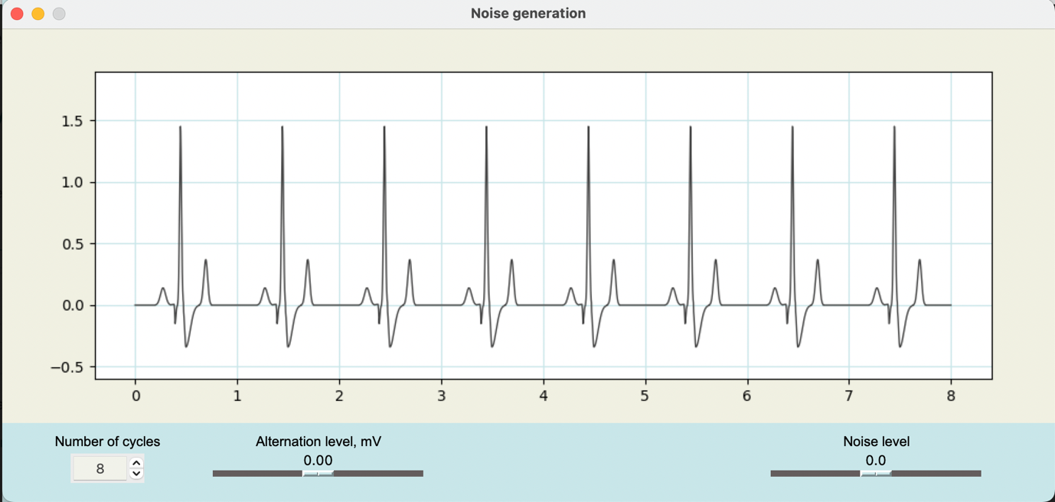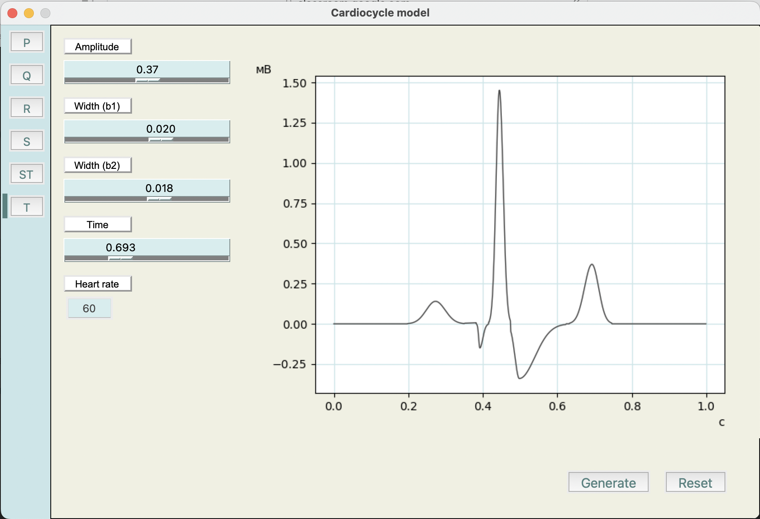Рис. 1. Кнопка GENERATE

Рис. 2. Вікно, що відкривається після натискання на кнопку

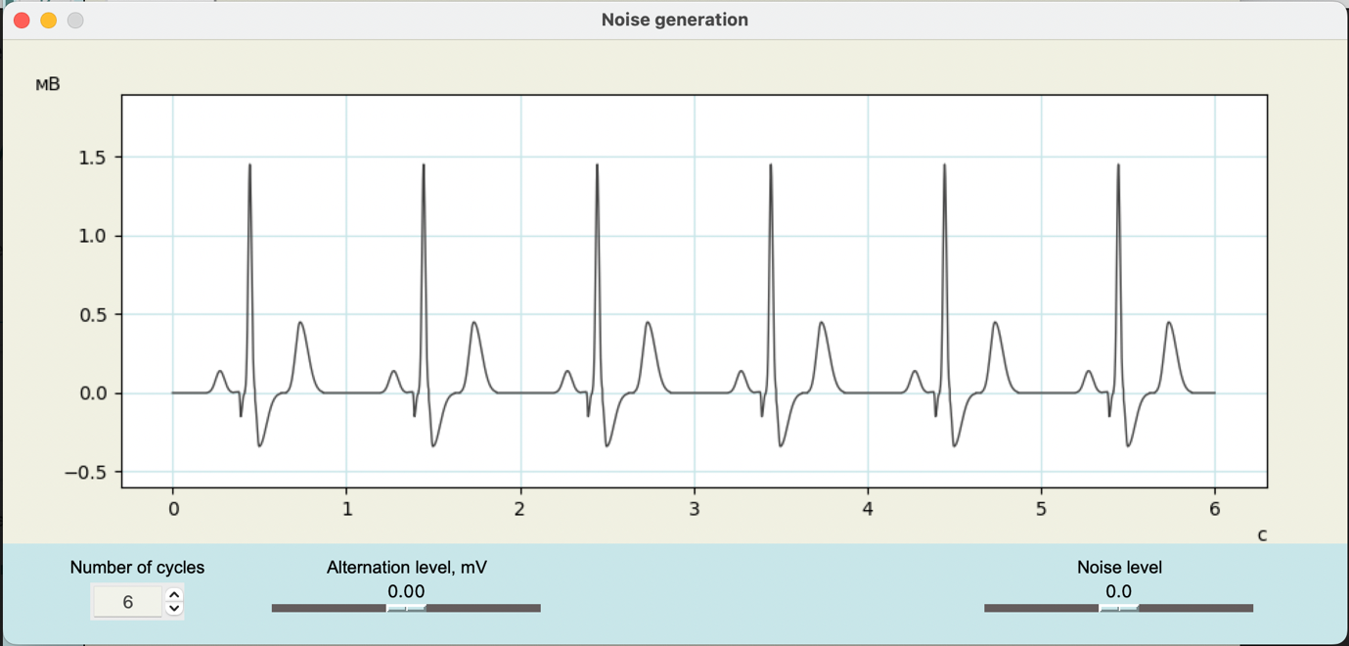

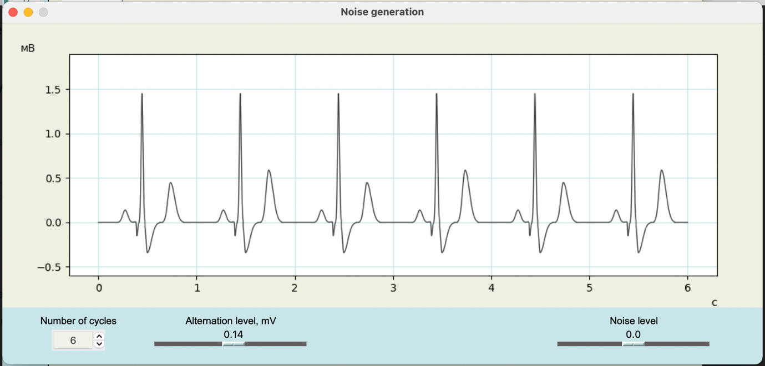Рис. 3. Можливість змінити кількість циклів

Рис. 4. Альтерація зубця Т

Висновок: у даній лабораторній роботі було виконано можливість генерації різної кількості циклів ЕКГ, та зміни амплітуди зубця Т. Завдання виконано мовою програмування Python, з використанням бібліотеки Tkinter для віконних додатків.